A Response to Alan Heldman’s New Experiment, etc.

Mr. Heldman’s new apparatus is truly fascinating, one that I had hoped to make, but he “beat me to it”. This was because I don’t have readily available machine tools, etc. Instead I chose to numerically model the pendulum with a spring-loaded support. This is relatively easy, as it’s a problem, or a similar one, offered in many intermediate physics texts. One introductory text, by using the small angle approximation avoids recourse to the Lagrangian derivation of the equations of motion. I initially used that text’s coupled equations, because they are relatively simple and readily numerically integrable. (Each equation contains only one acceleration.) The results, depending on the initial conditions and parameters (displacements; masses, spring constant, and rod length), were as expected intuitively, i.e. with weak coupling and equal natural frequencies the energy passes back and forth and with strong coupling, depending on the oscillators’ respective energies and inertia, one acted as a driver of the other. However, what I wanted to find was Mr. Heldman’s “flip flop” behavior. Because I did not, I assumed it was because he used large pendulum amplitudes (>> ~ 0.1 radian) for which those equations are rather invalid. Writing the Lagrangian is relatively easy, but plugging and chugging is rather hirsute. Fortunately, several authors have done this, so all I had to do was separate the accelerations by solving them for the second derivatives, substituting alternately, and then plugging them in to a leapfrog algorithm. I tested it by comparing a trial at small pendulum amplitude (0.01 radian) to French’s one with the same parameters. I had to do the separation several times before I found all the errors -- I hope! The following four figures display some data created by that program.
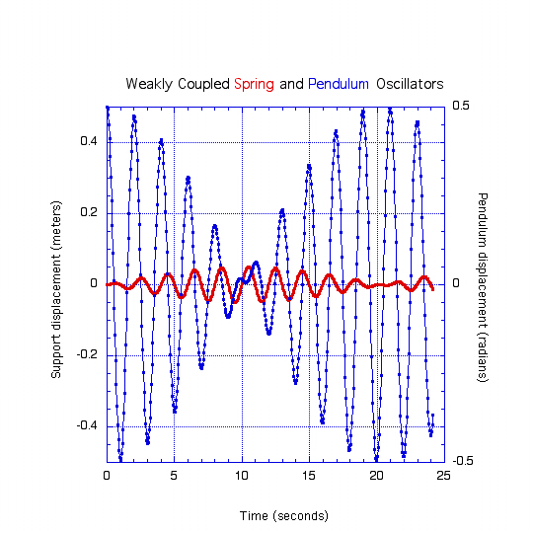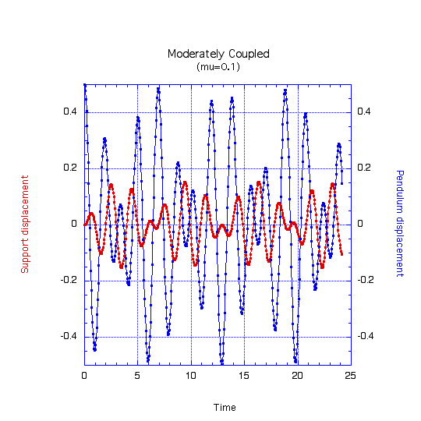
Fig. 1 Fig. 2

Fig. 1 The initial pendulum displacement is 0.5 radians (~ 29 deg.). The free (natural) periods of the oscillators are about two seconds. [g = k = 10 N/m; L = 1m, M1 = 1 kg]. The coupling is due to the mass of the bob (0.01 kg)
For Fig. 2 the parameters are the same as in Fig. 1, except the bob’s mass is greater (0.1 kg). A longer time series reveals the behavior is indeed chaotic, as it must be. I created the next two graphs for curiosity’s sake.
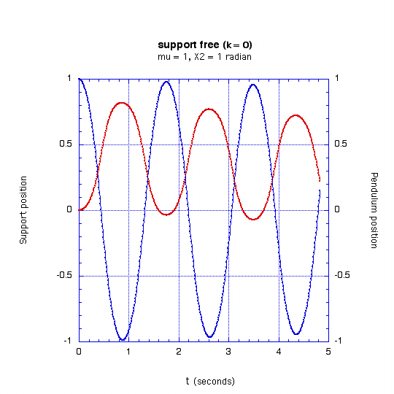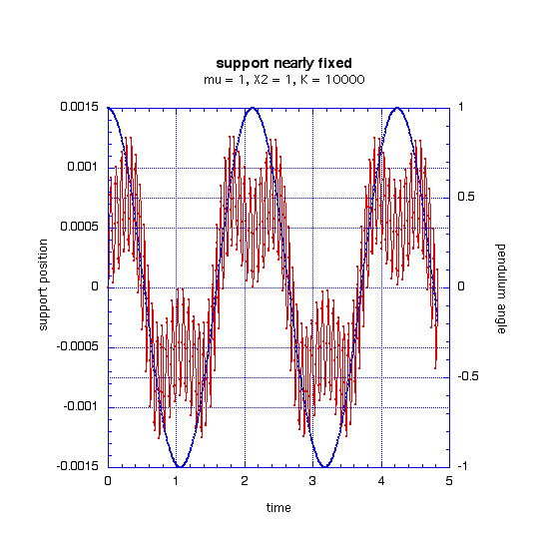
Fig. 3 Fig. 4

The Fig. 4 graph suggests attempting to model one of Mr. Heldman’s early experiments. He found the horizontal movement of the suspension about five microns from a 15.2 kg bob at an amplitude of 1.5 deg. (26.2 milliradians) This is equivalent to a spring constant of about 8 E+5 Newton/meter. (~ 4.6 k #/inch) The mass of the double plywood is approximately 3.4 kg and the Synchronome (without the pendulum) about the same. (The casting is 6.6 pounds.) Assuming no damping the result was quite similar except a higher ringing frequency and a further reduced response.

Returning to Mr. Heldman’s coupled oscillators: I have been unable to duplicate his apparatus’ behaviour, even with, what I presume is an exact model without damping. My only explanation is the springs are hard instead of linear and he used a large amplitude. He supplied no data except for one frequency and a mass range, and it is difficult to estimate the parameters of his apparatus. However, the spring constant can be derived from the given frequency and mass. As a result I plan to obtain a track for my Pasco very low friction reaction cart and mount it with springs. Perhaps I’ll be able to report in the next newsletter.

Mr. Heldman discusses the concept of resonance, which is indeed confusing. If an oscillator doesn’t oscillate is it one? Surely an oscillator that clearly does and then is over damped is an oscillator? How about changing the parameters, so the Q of a system not thought of as an oscillator is increased? For example, would not a much heavier back plate ring when struck with a hammer? I doubt, as Mr. Emerson wrote, the driving frequency of the pendulum is near the natural frequency of the support system, if it has one. (Vide the very approximate model above.) Regarding resonance: Only an oscillator may resonate. The amplitude of the resonance (or maximum response to forcing) is a direct function of its Q, and this maximum occurs when the driving frequency is the same as the oscillators natural or ringing frequency, or as Mr. Heldman wrote, the build up is greatest. This resonance frequency is very little different from the undamped frequency except at rather low Q’s. From my physical intuition, my calculations, and the response models I discuss below, I suspect there was no build up, but instead an error in measurement. This might have been verified except for screw failure.

Mr. Heldman was particularly “fascinated” with my 10% “rule”. It was the result of an estimate from several text graphs. From them one will find that to have a response of about three times greater than the forcing amplitude the Q must be approximately greater than three and then, with better calibrated eyes, no matter the Q, at approximately +/- 10% from the resonance peak the response never exceeds five times the forcing amplitude.
Because I had become somewhat adept at numerically modeling the coupled oscillators, I tried modeling a spring oscillator with various Qs. However, in the limited time available I was unable to “debug” the program sufficiently to achieve internal consistency. However, they are still instructive, so some examples follow.

Fig. 5: (next page) The Q is supposed to be 30, easily verified from the graph. From this free decay, I measured the oscillator’s natural frequency to insert it into the algorithm that created the next graph. (Fig. 6, next page)

Again the Q is supposed to be 30. The frequency is correct, as there is no transient behaviour, as is evident in the next graph. (Fig. 7, next page) The forcing amplitude is 0.1 meter.

A note about the algorithm: It is similar to the coupled oscillator one. To conserve space I have not included the two programs I wrote. I invite those interested to request them. For those not able to, I’ll run them with your supplied parameters. Remember, The Squeaky Person Is More Likely To Get The Cleyet. [<bernardcleyet@ redshift.com> (831) 771-2611]

A note about all the graphs: In order to save time I instructed the algorithm’s output to print the calculated results only every 100th iteration, or less often. The data points are rather accurate, though they sometimes don’t appear so.

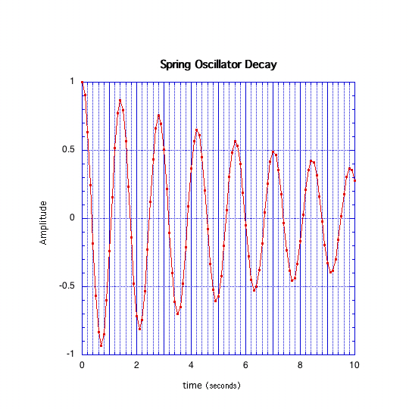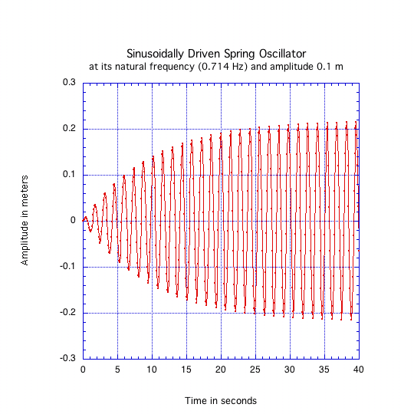

Fig. 5 Fig. 6
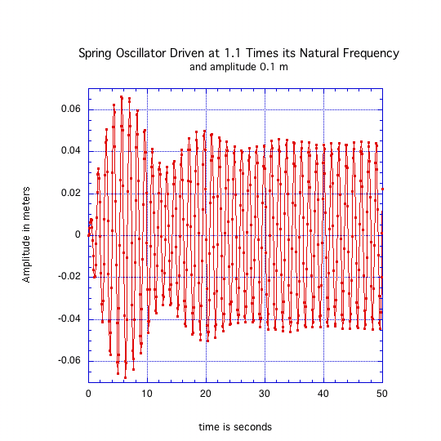
Fig. 7

Note particularly (Fig. 7) the very weak response, and that the transient is damped only after approximately 50 seconds. All appropriate parameters, etc. are the same as in the Fig. 6 graph except the driving frequency.

Again, obviously, I must duplicate, approximately, Mr. Heldman’s apparatus and compare with my numerical modeling and report back.

bernardcleyet@redshift.com

Thornton and Marian, Classical Dynamics (5th. Ed.) is the current upper division text at UCSC. Problem 12-18; Wells, Lagrangian Dynamics (Schaum’s outline 1967) Example 4.4 Pendulum with a sliding support. (The previous two treat the support mass as free.); Cooper & Pelligrini, Modern Analytic mechanics (1999), Example 5.4.2 Sliding [spring loaded] Mass with Pendulum.
Not necessary, but somewhat simpler than just using Newton’s second law and isolated body diagrams. French, Vibrations and Waves (1971) Problem 5-11. The solution is given on line: http://ocw.mit.edu/OcwWeb/Physics/8-03Fall-2004/VideoLectures/
described in detail by Eisberg and Lerner, PHYSICS, Foundations and Applications; and Feynman, et al. The Feynman Lectures on Physics.
Generally a non-linear coupled oscillator system may be driven into chaos and the pendulum is certainly one. I know of no exceptions.
Horizontal force is ~ mgA, 15.2*10*26E-3 ~ 4 N
Three quarter plywood density is (areal) ~ 9.5 kg/m^2, from a sample I measured. Then I reread Mr. Heldman’s article; the factor of two difference is indeed worrying.
Personal communication, Mr. B. Mumford
More than grossly wrong. If the system is an oscillator, I “guesstimate” the Q is about one. The support tines (posts) may “ring”, but supersonically, and are heavily damped by their huge base and close coupling to the plywood.
A non-linear pendulum, and springs can be very linear (<< 1% deviation).
A hard spring is one whose constant increases with stretching. A common example is a gas filled bladder. Obviously, a coil spring when nearly uncoiled becomes much harder. The reverse physics term, not surprisingly, is “soft”.
They have replaced air tracks, because of their convenience, and the friction is almost as low. A further advantage is they support much more weight than air carts.
My experience recently with #10 stainless deck screws. Must be predrilled when used in pressure treated lumber.
Perhaps the apothegm, “He who finds Chi (square) by eye deserves what he gets.” is applicable here.
Good examples are found in Baker and Blackburn “The Pendulum” (Unfortunately, one must convert the damping constant to Q if one has a better apprehension of Q.); A.P. French, Vibrations and Waves; Braddick, Vibrations, waves, and diffraction, and probably many of the more complete intro. Physics texts.

