Half life DEMONSTRATION

This note gives additional information on the half life demonstration I preformed recently.

The figure below shows the radioactive decay scheme.

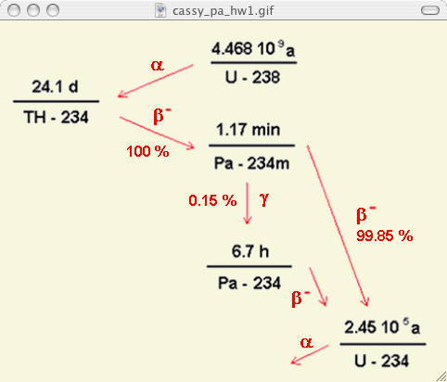

On the next page is a graph of the data collected during the first class. I have fitted the data, after removing the initial and some final background points, to the three coefficient exponential decay equation:

Where is the number of counts / 5 s, = - at 0 [the initial rate due to the source only]; is the decay constant, is the time (s), and is the background (counts / 5s). Note the half life is, . Therefore, the measured half life is 70 s (1.17 min.) in agreement w/ the standard value given above.

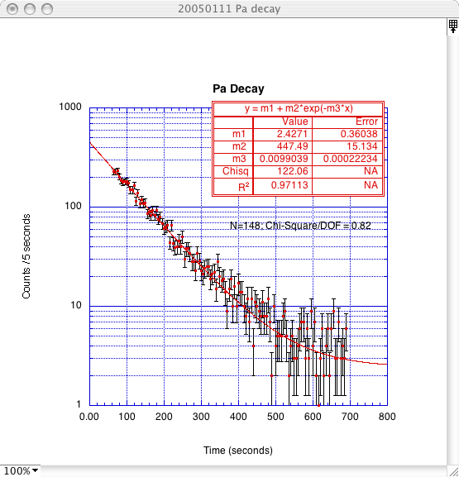

Note that the scatter is a function of the number of counts. (It is approximately equal to the square root of the number.) The error bars are + & - the Std. Deviation. Because nuclear decay observes a Poisson distribution, the Std. Deviation is the square root of the number of counts, therefore, one may easily test the data using the Chi Square test for “goodness” of fit to a proposed function. The Chi Square is the sum of the squares of the deviations from the function divided by the SD. i.e. . Intuitively, if the sum divided by the number of points is approximately one, then one may conclude the data is described by the function. More exactly one may use the Chi Square function distribution. From the plot below one estimates the probability the data does not fit is ~< 5%.

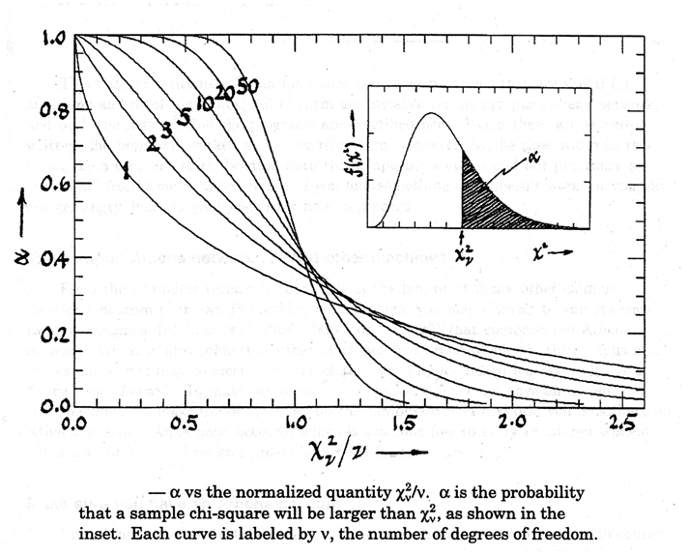

is the number of independent points or degrees of freedom, in this case the number of data points – 3.)

the below site includes applets for calculating Alpha, inter alia.

http://www.fourmilab.ch/rpkp/experiments/analysis/chiCalc.html

Mathematical details:

http://www.fourmilab.ch/rpkp/experiments/statistics.html

